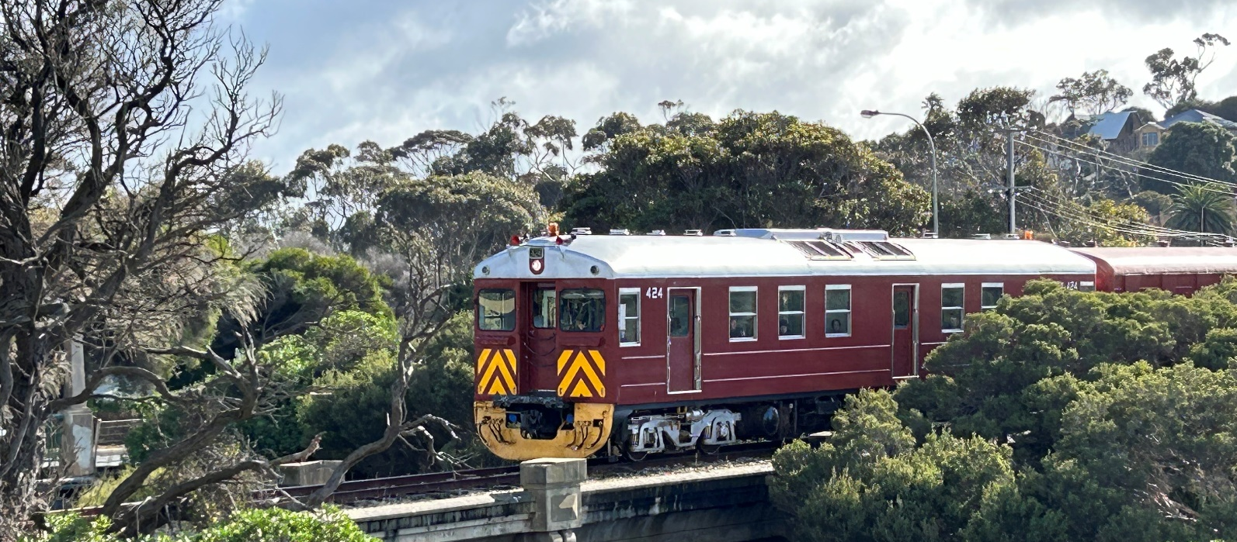



People
Eleanor is making slow progress. Pray that her wound will heal soon.
Sun Sep 13 – Rev’d J McWhinney*
Sun Sep 20 – Rev’d L Linggood, Presbytery Minister POSSA ***
Sun Sep 27– Rev’d J McWhinney *
Sun Oct 4 – Rev’d S Kadaparambil, Frontier Services
HC **
Sun Oct 11 – Rev’d J McWhinney *
* Morning tea after the service
** Church lunch at Middleton Tavern at noon
*** Footy Finals pies & pasties after the service
Cockle Train Victor Harbor photo courtesy Jaelene Slade
Adare Uniting Church — Update 36, September 11, 2026


LECTIONARY READINGS
Sunday September 13
Exodus 14:19–31
Psalm 114 or
Exodus 15:1b–11, 20–21
Romans 14:1–12
Matthew 18:21–35

Rev’d Janice‘s days off:
every Friday until the end of September.

Pleasant Sunday Afternoon
Sunday 27 September 2026 at 2 pm.
A special Pleasant Sunday Afternoon will be held at 2 pm to celebrate the moments that shaped the congregation through music, song and stories. Come and celebrate with us, catch up with old friends, reminisce on cherished memories and experience the warmth of the Adare congregation once more.
Join us for afternoon tea.
We would really love to see you!

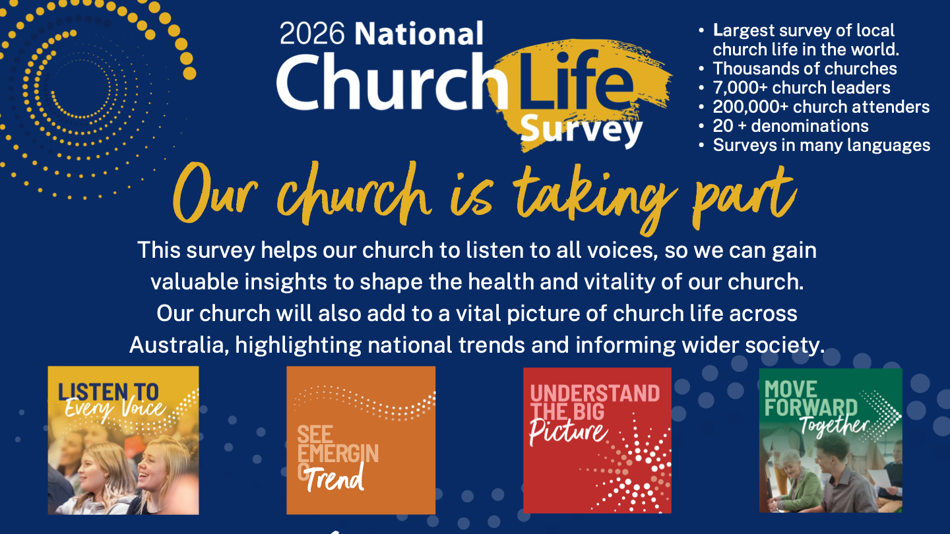
BIRTHDAYs
Dean Wickham 15/09
Julianne Smithson 17/09
When your birthday is listed, please check your pigeon-hole and receive your birthday surprise!

WEDDING ANNIVERSARies
Bryan & Janet Ezard
11/09/1965
David & Pat Keep
14/09/1974

Victor harbor men’s shed
Bunnings Barbecue Saturday 19 September
Garage Sale
Saturday 3 October

Marriage advice from 1886
Let your love be stronger than your hate or anger.
Learn the wisdom of compromise, for it is better to bend a little than to break.
Believe the best rather than the worst.
People have a way of living up or down to your opinion of them.
Remember that true friendship is the basis for any lasting relationship. The person you choose to marry is deserving of the courtesies and kindnesses you bestow on your friends.
Jane Wells (1886)
Submitted by Carol Abbs
Lunch Fellowship!
A time to gather over a shared a meal and fellowship.
Date: Sunday 4 October
Time: 12 noon
Location: Middleton Tavern,
37 Goolwa Rd, Middleton

RSVP Dean Wickham by Friday 2 October. All welcome!
NCLS (National Church Life Survey) October 2026
The National Church Life Survey is a survey for individual congregation members to complete, to capture your experiences and perspectives. You can complete the survey
on-line or use a paper copy.
Please let Janice know by Sunday 27 September if you are interested in participating.

news from uniting church SA
Pokies-free hotels – we need your help
One of the suggestions that came out of working group discussions about gambling reform at the recent Synod meeting was to promote hotels and venues that don't have pokies….
The intention is to make a list available widely to encourage people to think about the places they choose to patronise, and provide a list of places they can visit that are pokie-free.
Please email me (slitchfield@sa.uca.org.au) places near you or that you have visited that are pokie-free. [From Rev Scott Litchfield]
…………………………………………………..………..
Orchid Show this weekend
WHAT: Orchid Show
WHEN: Saturday 12 September (9 am–3 pm) and Sunday 13 September (12–3pm)
WHERE: Western Link Uniting Church, 93 Crittenden Rd, Findon SA 5023.
Beautiful orchids will be available to admire or purchase. $5 entry fee includes a cup of tea/coffee and a biscuit. Enquiries can be directed to Ralph Edwards at 0455 973 703.
…………………………………………………..………..
Call for liturgy writers
Join a team of writers for lectionary-based worship resources – Words for Worship and Liturgy, Learning and Life. Participate in a creative process as together we support the worshipping life of the church. Writers receive an honorarium for each manuscript.
Send expressions of interest to Mission Resourcing Publications Coordinator Christine Gilbert by 15 September (cgilbert@sa.uca.org.au).


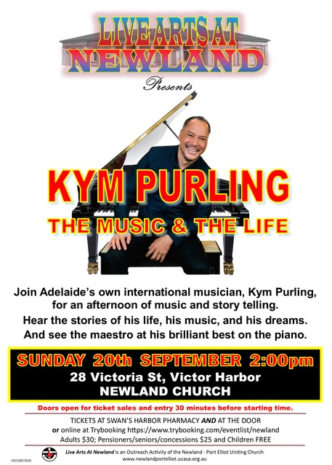
A few must-reads!
Archery by Beau N Arrow
Split personalities by Jacqueline Hyde
Desert travel by Rhoda Camel
Dog of prayer by Saint Bernard
The kennel is my home by Jack Russell
Kung Fu for beginners by Marcia Larts
School truancy by Marcus Absent
Let me know what books YOU recommend!

